架設中文教學雲端多媒體教室
OCAC WordPress Guide

WordPress Week 2 06/05/2016

How to Log In
Step 1: Search up your website using (Your login initials).vistait.school/admin
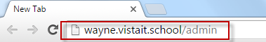
Step 2: Enter your username (Initials) and your password
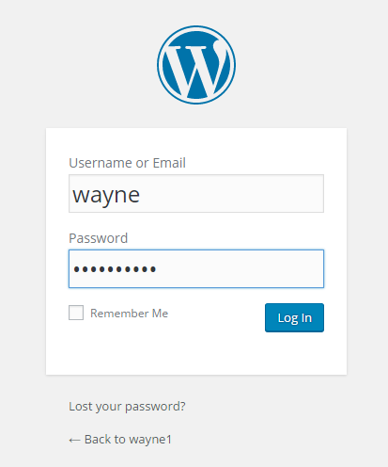
Step 3: Login and get started!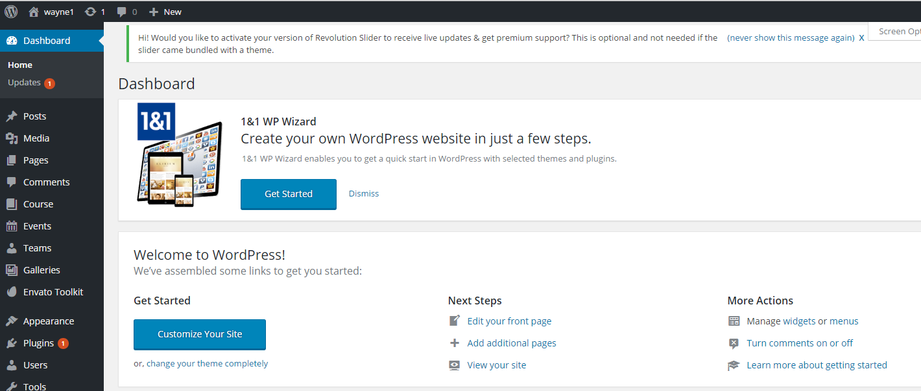

How to Create a New Post

Creating a new post for your blog or website is a great way for people to stay updated with new and relevant information going on with your site.
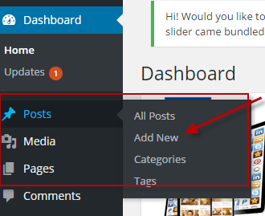
Step 1: Locate your Posts option on your left hand side of the screen
Step 2: Select Posts and click to add a new post
Step 3: Complete your post with whatever information you would like to update your website with.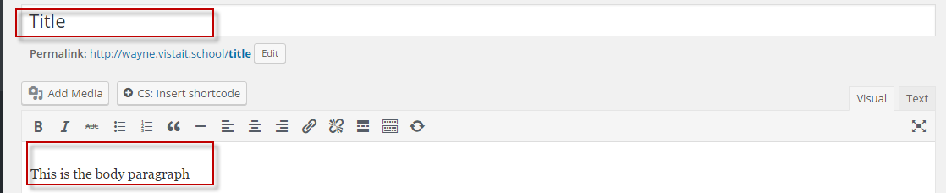
Step 4: When you are done don’t forget to pick a category of where this post belongs to. 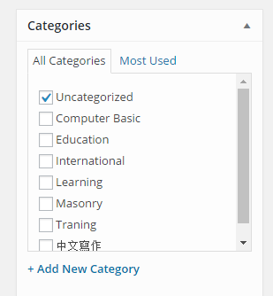

Step 5: After picking out a category you can publish your post. 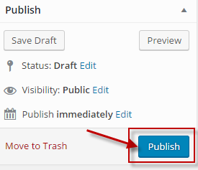

How to add Categories

Step 1: On your dashboard locate the posts and select the categories option. 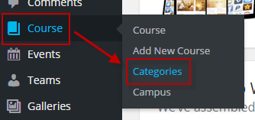
Step 2: Create a title for your category
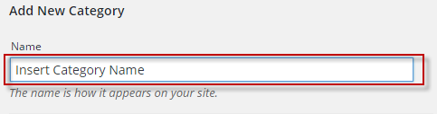
Step 3: Add a description to help better describe your category
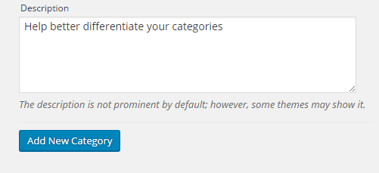
Step 4: Once you have completed the above steps proceed to add your new category.
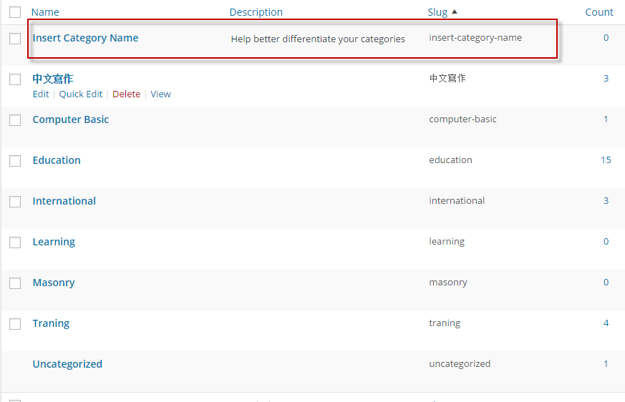

Adding Media to Your Page
Pictures or songs can easily make any page more interesting and engaging to read. Simply follow these easy steps to learn how to add media to make your work more interesting.
Step 1: Start by creating a page or post.
Step 2: Locate the Add Media Option and click on it. From here you will see images or songs you may have already inserted. 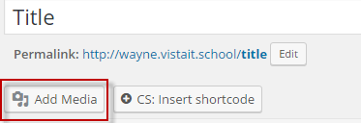
Step 3: Go to the upload files option and choose to either upload files by either dragging them in or selecting them from files. 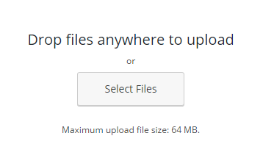

Step 4: Once you are done, you can choose to upload them by inserting it into your post.
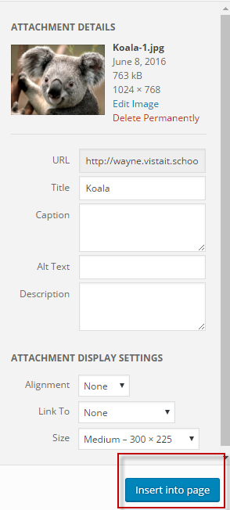
Step 5: Once you click insert into page you will see your photo in your post.
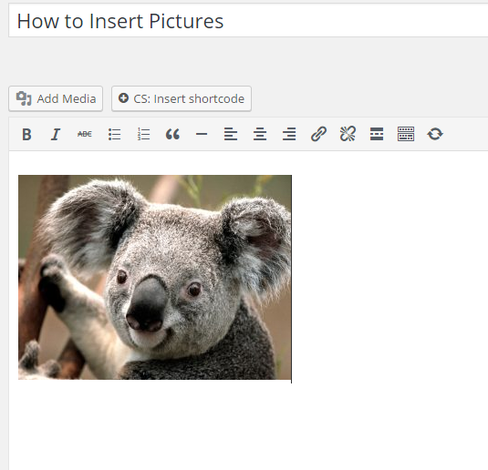
Notes: You can make a playlist or photo gallery using the additional options on the left. Using a gallery or playlist will allow you display multiple pictures or songs easily.
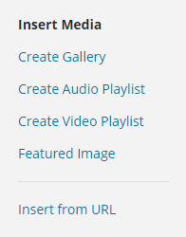

Inserting YouTube links
Step 1: Pick any video and go down to the share button and click it.
Step 2: After clicking the share button proceed to press the embed button and copy the link.
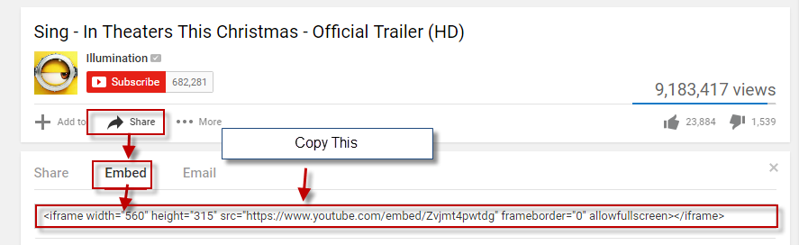

Step 3: On an existing or new page, click on the text item box in order to access the code.

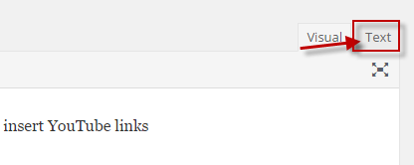
Step 4: Once you have opened up the text item, continue to paste the link into the box. 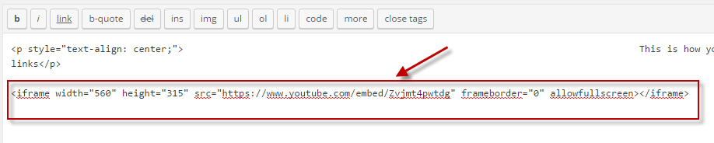

Step 5: Go back to the visual box and now you can watch YouTube videos on your website.
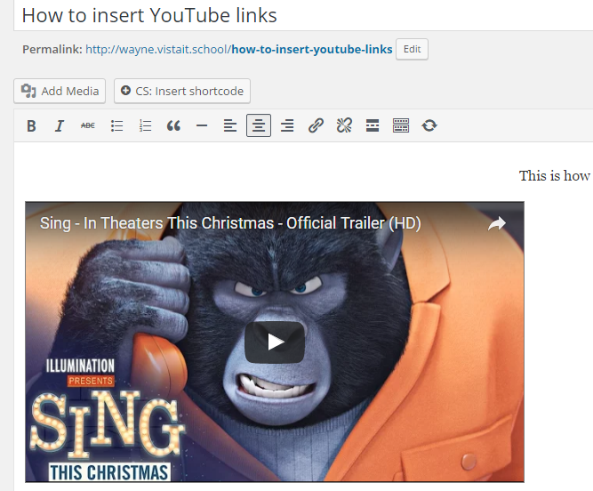

How to add a Menu
Step 1: Locate the appearance option on the left hand side and select menus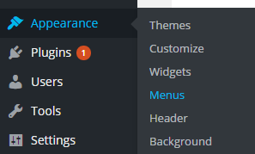

Step 2: Click on the Create New Menu option
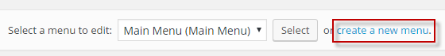

Step 3: Give your menu a name and create it
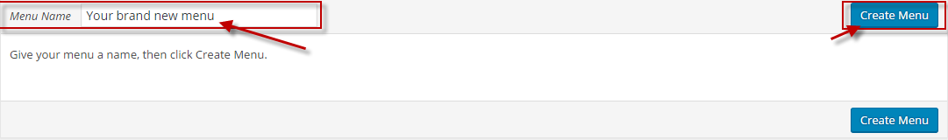

Step 4: Choose what kind of menu it is and add pages to your menu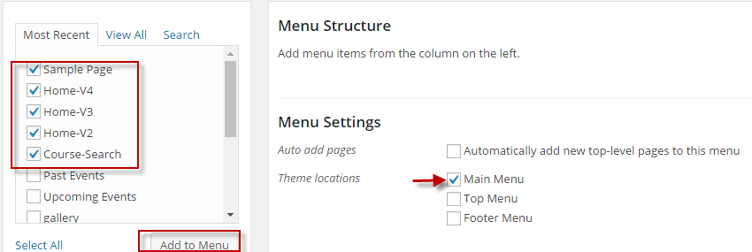
Step 5: Once you have configured your menu, you can create sub-menus by dragging a menu underneath the one on top. 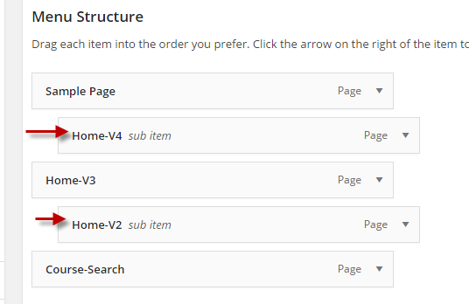

Step 6: Once you have arranged the menus to how you would like, save it and then check back to see your menus.
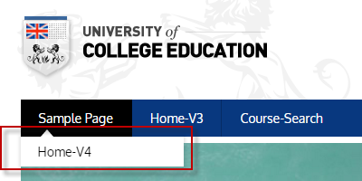

How to Add a New Page
Adding a new page can be a very simple thing once you get the hang out it.
Step 1: Locate your tool bar on the left.
Step 2: Find the pages option.
Step 3: Click pages and select Add New.
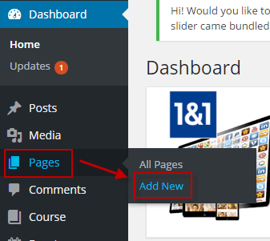
Step 4: Fill out your page with a title and information.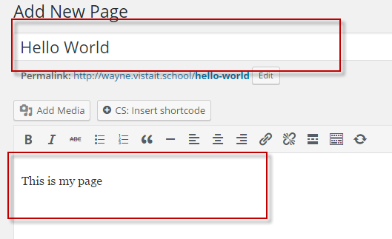
Step 5: When you are done then you can publish your page for everyone to see!

Tips
- Use the tool bar to your advantage. You can toggle the tool bar to give you more access to tools. 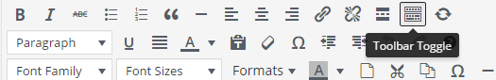

- You can edit when and how your page gets published with settings like Visibility and Publish.'

- The status of your page can easily be changed by changing the status of your page.

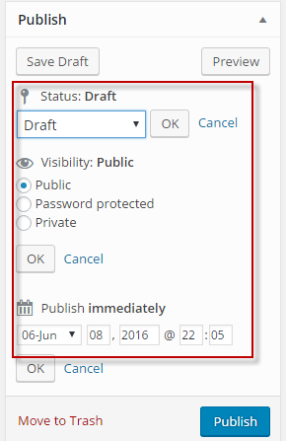

WordPress Week 3: 6/12/16

Menu Setting
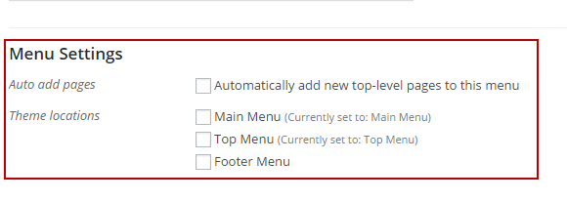
When creating menus, don’t forget to check what kind of menu you want to choose.

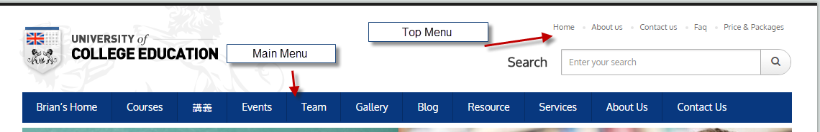

Adding Events
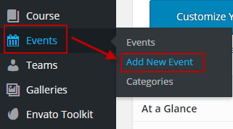
Step 1: On the left hand side of your screen, locate the events option and choose Add New Event.
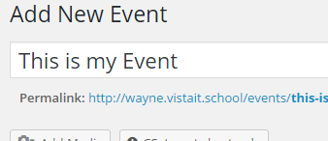
Step 2: Give your event a title to explain what your event is about.
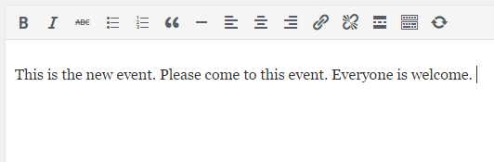
Step 3: Use the body to create a description regarding your event.
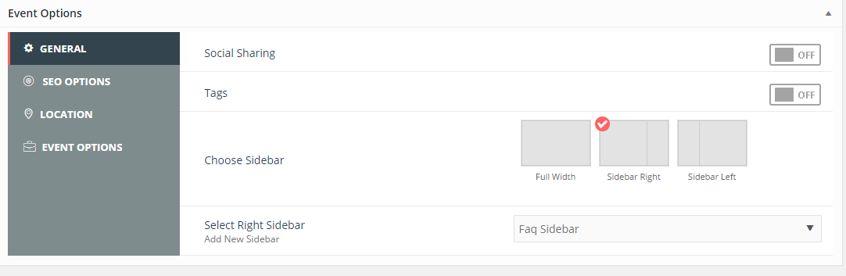
Step 4: Scroll down the page to locate the Event Options. This will allow you to better advertise your event.
Social Sharing: Allows people to share your even through mediums like Facebook, Twitter, YouTube etc.
Sidebar Left/Right: Positions the sidebar left/right respectively.

SEO (Search Engine Optimization) Options: This option allows you to better search for key words or terms in your website.
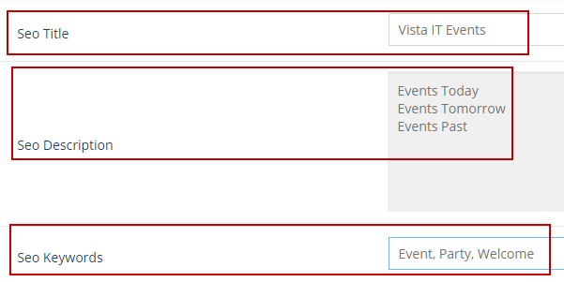

SEO Title- The title you see when you Google search for certain pages
SEO Description: What information will show up when you search things up
SEO Keywords to help better find certain pages
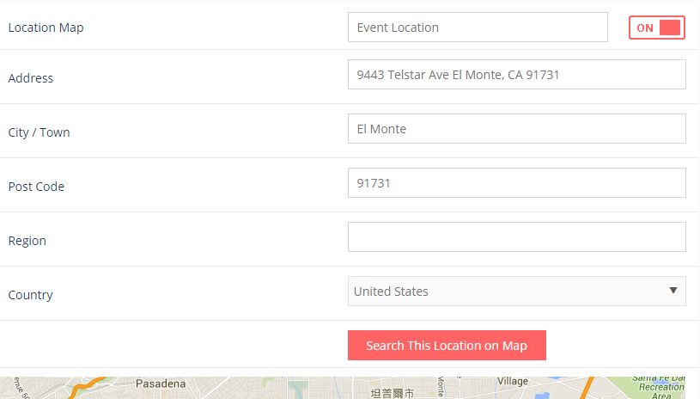

Step 5: Use the Location setting to help viewers better understand where your event is being held at or taking place.
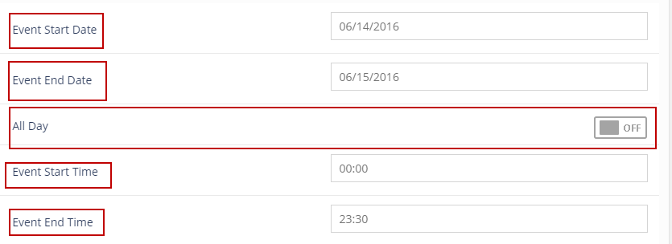
Step 6: Using the Event Options, set information regarding your event such as when it starts and ticket options.
Event Start Date: What day does your event start?
Event End Date: What day does your event end?
All Day: Is this event an all-day event? Or are there hours like 9 – 6?
Event Start Time: What times does your even start?
Event End time: What time does your event end?
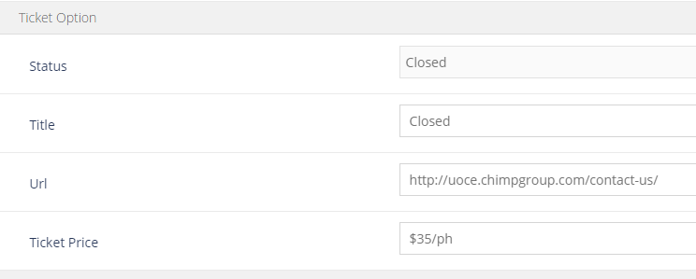
There are also ticket options to help sell tickets for your event if it costs money. 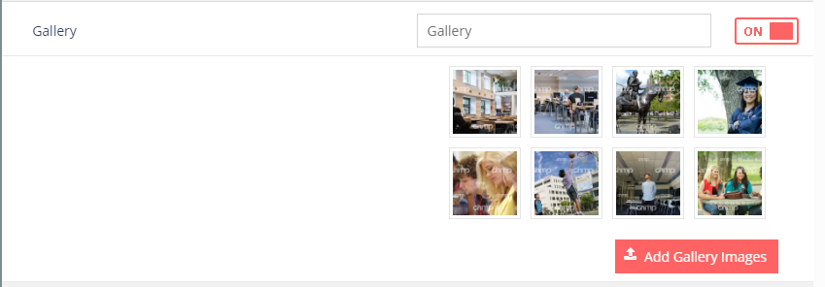
Another option you have when creating your events, is adding pictures to help form a gallery. This helps people know what they can expect in the event. 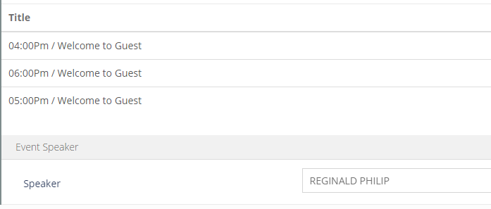
Using this function, you can help form a program of what is going to happen during this event as well as who will be speakers if any are going to present.

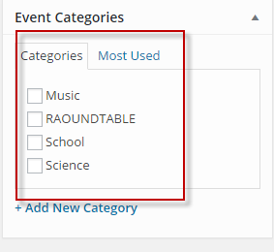
At the very end, don’t forget to choose a category that the event goes under.

Word Press Week 4
Courses
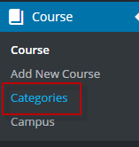
Step 1: Before adding in courses for your site, when looking for the courses section and choose the categories option.
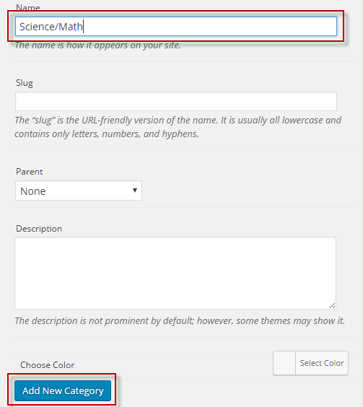
Step 2: Name your Category to help better understand what kind of course you will be offering. When you are done, you choose to add it to a list of categories you may already have.
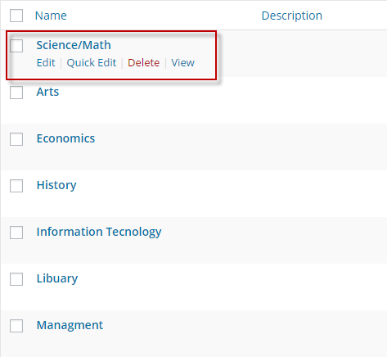
Step 3: You can see that now your category has been added to a list of other categories. Once you have the appropriate category created for your course, proceed to go make a course.
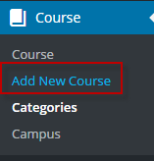
Step 4: Return back to the courses option and this time, choose to Add New Course.
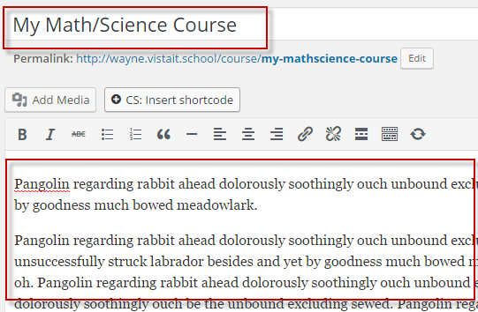
Step 5: When creating your course, don’t forget to choose a title that best describe your course. Also add a brief description to help better explain what your course will teach or do.
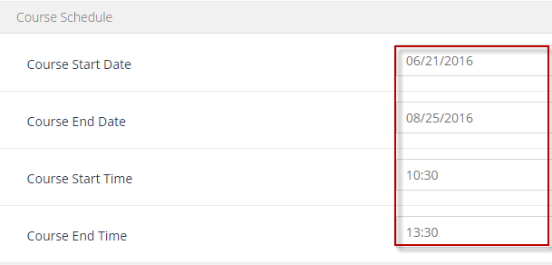
Step 6: Enhance your course by better explaining when it will start and when it will end.
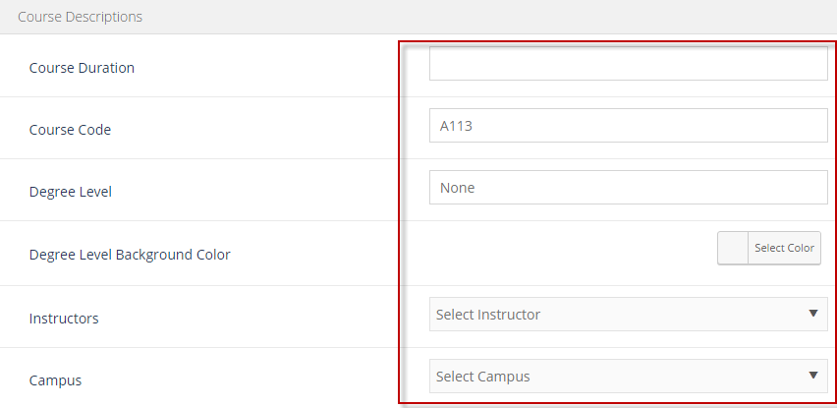
Step 7: Add other information like duration and prerequisites that the course may require. You can also include what instructors are going to be teaching as well as where the class is taking place at.
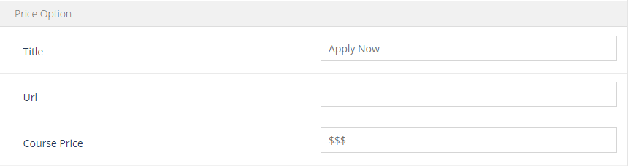
Step 8: Additional information you can add includes whether or not your course costs money or not.

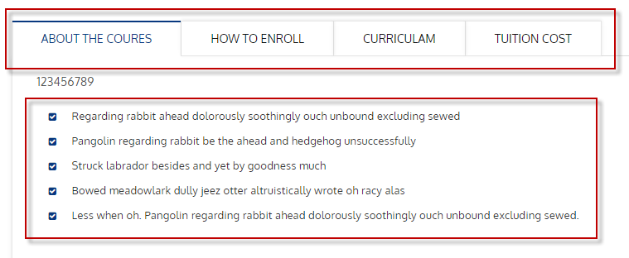
Step 9: Adding a Tab Short code will allow you to better display information on your courses.

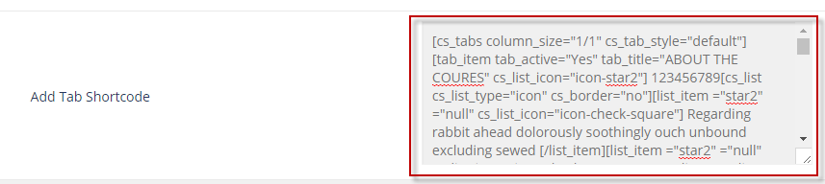

Step 10: Paste the code into your short tab box.
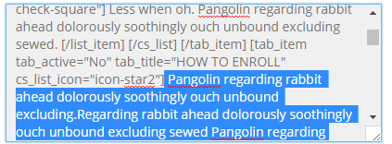
Step 11: Highlight all the unnecessary text and replace with your own words.
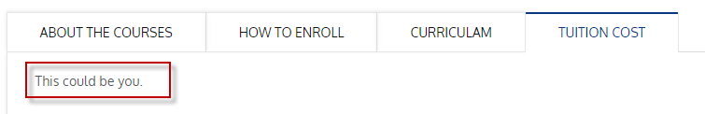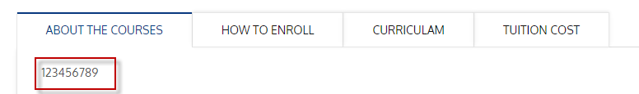

Step 12: You can see that there is now a bar that gives you more options in your description. Changing the short code allows you to enhance your content in the description.

WordPress Week 5

Creating Galleries
Creating a gallery is very easy to do. Not only that but it also helps enhance the picture experience of your website.
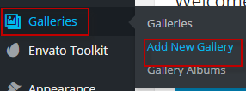
Step 1: On the left hand side of your screen, locate the Galleries options and proceed to Add New Gallery.
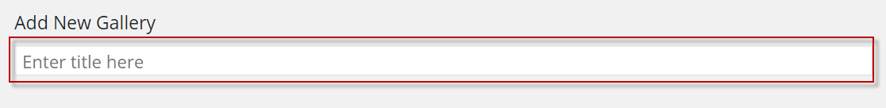
Step 2: Begin by giving your gallery a new name. This can be any name to help you better organize what gallery contains what.
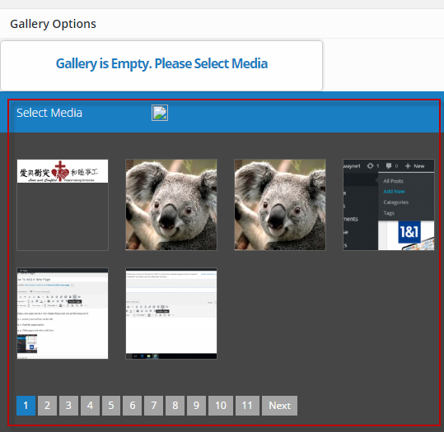
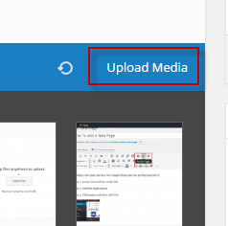
Step 3: Browse through your media. This box contains pictures you have already uploaded to the site. If there is a picture you don’t already have, then you can choose to upload it through Upload Media.
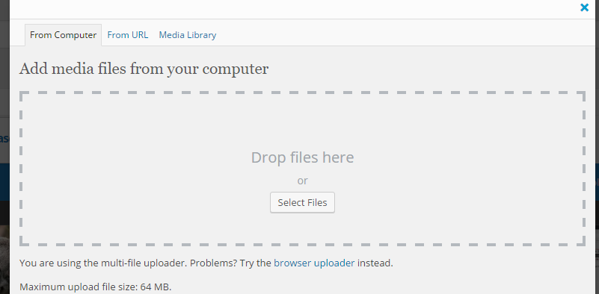

Step 4: If you need to add more pictures, then upload the files from this page after choosing to upload media.
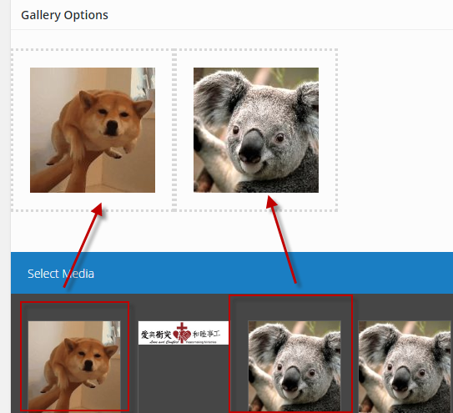
Step 5: Select your pictures by simply clicking on the picture you want to add. This will allow you to upload the pictures into your gallery.
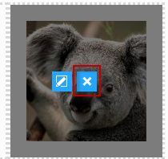
Step 6: If there is an image you don’t want, you can simply delete it by hovering over the picture and clicking on the x.
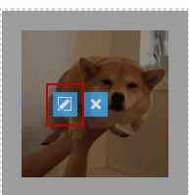
On the flipside, if you want to edit some information about the picture, you can click this pencil icon on the right. 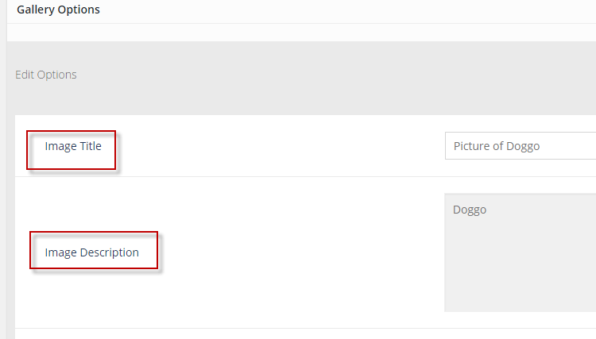
This will let you further explain what your picture is about. You can edit things like image title and its description.
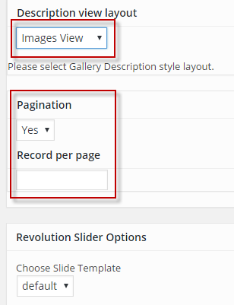
Other options include the ability to change how people will see the pictures will be displayed. For example, you can change it to be image view or carousal view. Pagination will allow you to edit how many pages there will be.
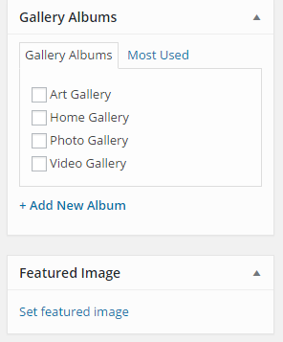
Step 7: If you want, you can put your gallery in a category it most relates to. Once you are done you can choose to upload a feature image so the gallery will feature an image that best portrays your gallery.

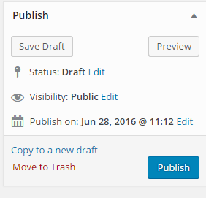
Step 8: When you are done with your gallery you can publish it and let the world enjoy it.

Navigating CS Page Builder
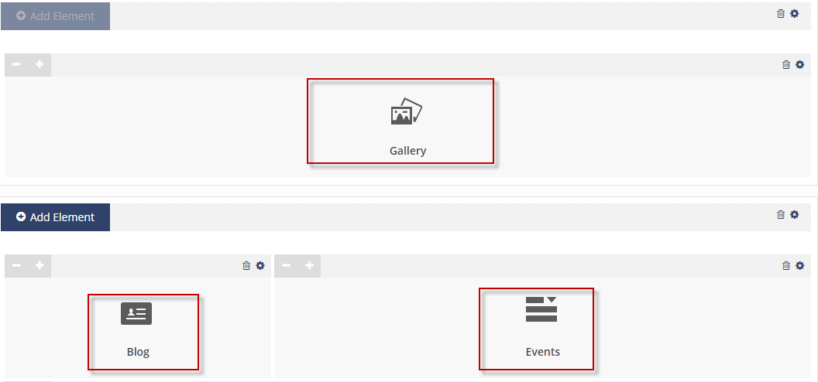

There are a lot of things on the CS Page Builder that can really enhance your work. With so many things however, it can be easy to lost track of what does what. Each of these can be adjusted in size on the
Gallery: Lets you display a gallery that you have made.
Blog: Shows posts you have made on your website.
Events: Displays the upcoming or past events.
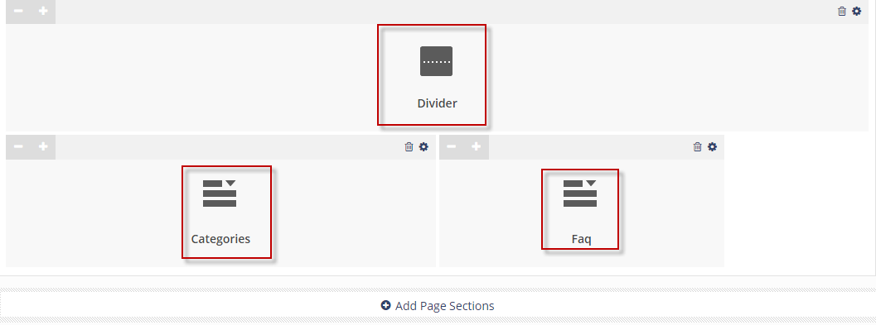
Divider: Divides the page to help with clarity
Categories: Displays the categories you have in your website.
FAQ: Showcases your frequently asked questions.
An Important thing to know is that you can further edit and customize things by clicking on the gear/settings option.
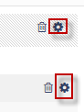

CS Theme Options
The key to making your website even better, is to play around with the CS theme options. This allows you to further customize your website.
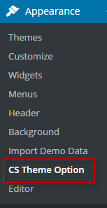
Step 1: Locate the Appearance Option and click on CS Theme Options
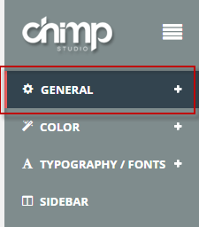
Step 2: Click on the General Setting and select the Header Option
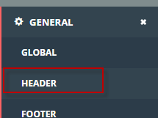

Step 3: Choose to upload a logo from your library or add a file to help create your header. 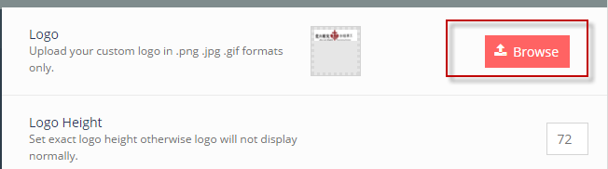

Step 4: Find a picture to add a choose select file.
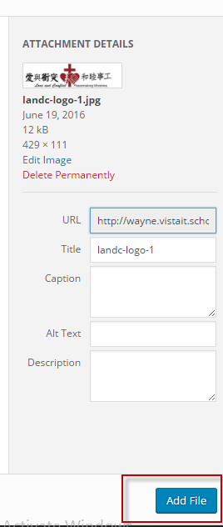
Step 5: Adjust the logo specifications to help ensure your header is perfect.

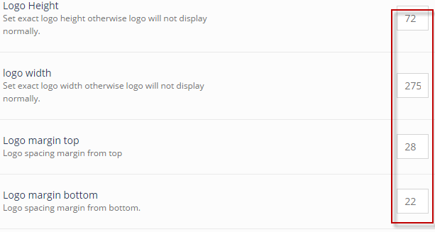
Step 6: When you are done, don’t forget to save the settings.
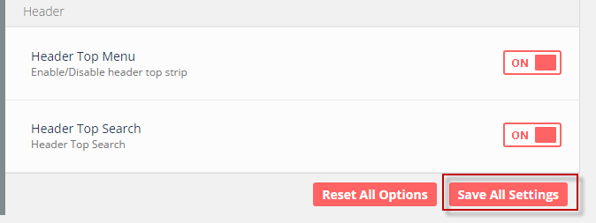

Adding Header
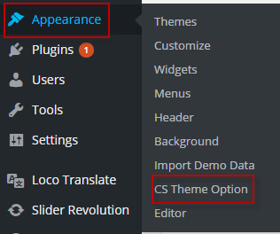
Step 1: Locate the Appearance and select the CS Theme Option.
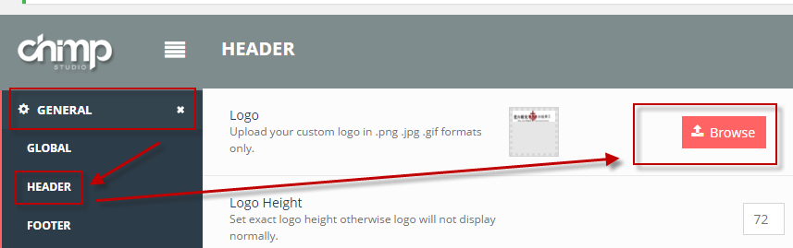
Step 2: Click General and proceed to click on Header. This will allow you to choose a logo to help create your header.
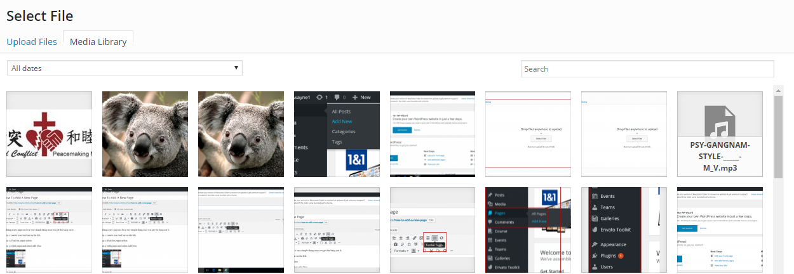

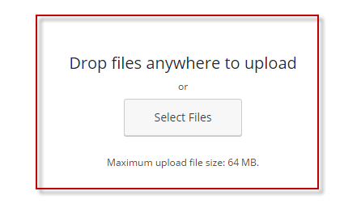
Step 3: Upon browsing, you will be taken to media you have already uploaded. You can choose to upload an image if it isn’t in the website already.
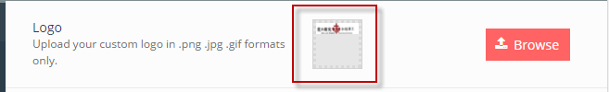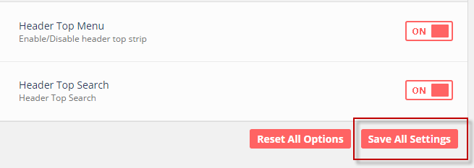
Step 4: When selecting your logo, the logo will appear in a box. Once this is done, you can save the settings to choose a header suitable for your website.

